Risen Savior Academy
PARENT & STUDENT HANDBOOK
2024 – 2025

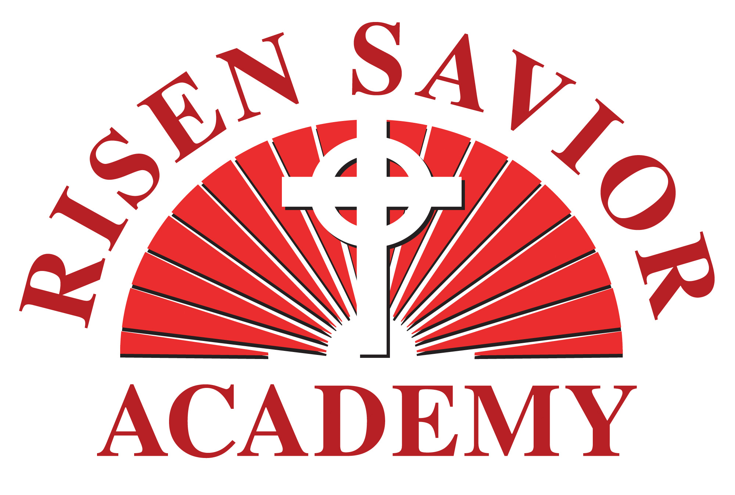
Risen Savior Academy
1331 S. Alafaya Trail
Orlando, Florida 32828
407-207-8500
Website: risensavioracademy.net
email: risensavior@bellsouth.net

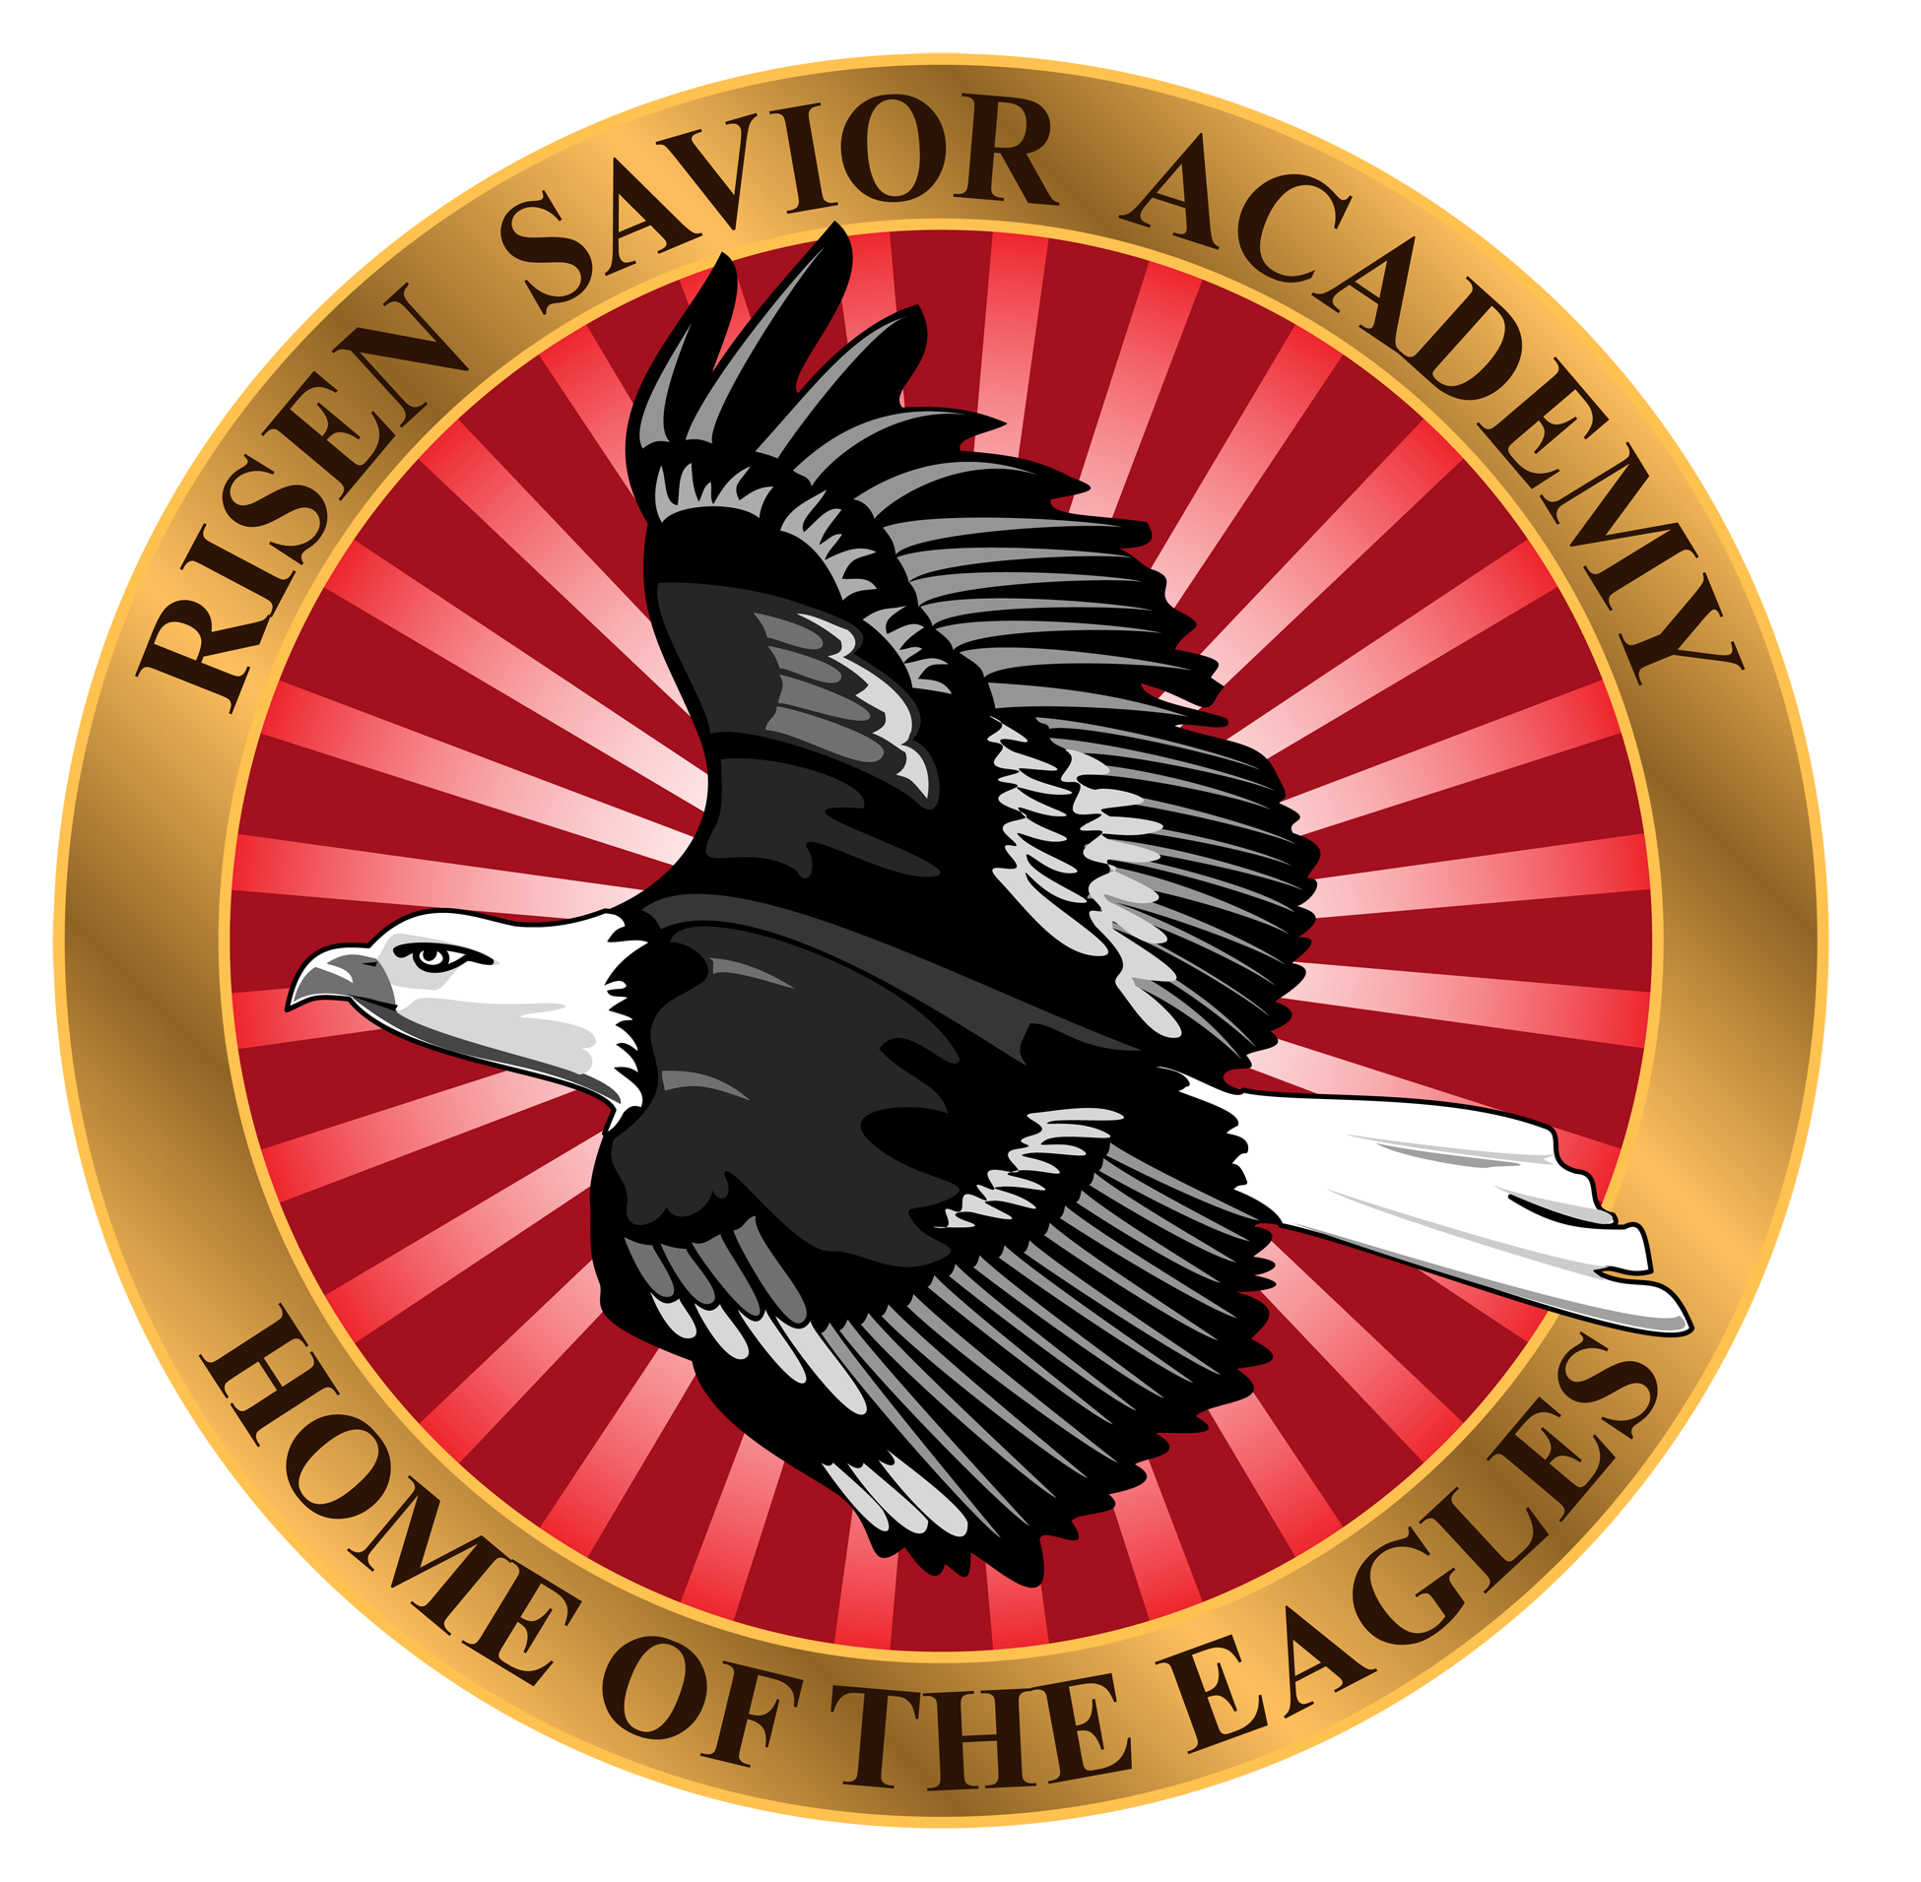

WELCOME TO RISEN SAVIOR

Dear Parents:

It is with great pleasure that we welcome you and your child (ren) to Risen Savior Academy! We are appreciative of the confidence you have shown in allowing us to teach and train your children. We eagerly look forward to partnering with you in educating and enlightening the next generation of young leaders.

The administration, teachers, and staff of RSA value excellence in education and we hold ourselves accountable for a thorough education of the whole child – mind, body, and spirit. Every aspect of our school conveys dedication to excellence: a challenging curriculum; a safe, structured, nurturing learning environment; a desirable student-to-teacher ratio; just to mention a few.

We trust that this handbook will help you to better understand our program of quality Christian education at RSA. We encourage you to carefully read and discuss it with your children and welcome the opportunity to answer any questions you might yet have.

RISEN SAVIOR ACADEMY

Is a member of the Wisconsin Evangelical Lutheran Synod, a church body that supports the fourth-largest private school system in our nation. However, it is independently operated by Risen Savior Lutheran Church and is governed by our congregation.

TABLE OF CONTENTS
TABLE OF CONTENTS……………………………………….……………………………………..…3
TRADITION OF EXCELLENCE……...…..…………………………………………………………….4

STATEMENT OF EXCELLENCE………………………………………………………………………..4
STATEMENT OF NON-DISCRIMINATION……………..……………………………………………4

VISION OF RISEN SAVIOR……………………………………………..…………………………….5
MISSION & PURPOSE OF RISEN SAVIOR…………………………………………………………5

SCHOOL STRUCTURE AND GOVERNANCE…………………………………………………………6

LEARNING ENVIRONMENT…………………………………………………….……….……….…..7
CURRICULUM ……………………………………………………………………………….………...7

ADMISSION GUIDELINES…………………………………………………………………………….8

ENROLLMENT REQUIREMENTS………………………………………………….………………….8
REQUIRED FORMS…………………………………………………………………………………....8

PHYSICALLY AND/OR LEARNING CHALLENGED ………………………………………………...9
SCHOOL HOURS OF OPERATION ………………………………………………..……………….. 9

PARKING LOT SAFETY..........................…………………………………………………………....9
ATTENDANCE ………………………………………………………………………………………..10

TUITION AND FEES.. ………………………………………………………………………………..10

OUTSIDE VISITORS …………………………………………………………………………………11
SCHOOL CLOSING …………………………………………………………………………………..11

FIELD TRIPS ………………………………………………………………………………………….11
LUNCHES/SNACKS………………………………………………………………………………….12

ILLNESS ……………………………………………………………………………………………….12
HEALTH & SAFETY …………………………………………………………………………………13

DISCIPLINE …………………………………………………………………………………………..14

CLOTHING ……………………………………………………………………………………………17
DAMAGES ……………………………………………………………………………………………17

INSURANCE ………………………………………………………………………………………….17
COMMUNICATION …………………………………………………………………………………17

COMMENTS & CONCERNS ……………………………………………………………………….19
CONTACT INFORMATION …………………………………………………………………………19
PARENT AGREEMENT.................................................................................20
TRADITION OF EXCELLENCE
The Wisconsin Evangelical Lutheran Synod (WELS) has a rich tradition of academic excellence in its Preschool through Grade 12 school system. The WELS has operated highly regarded schools across the United States, the Caribbean, and elsewhere in the world for over 150 years. Currently, WELS churches and associations operate 396 early childhood centers, 345 elementary schools, and 26 high schools across the nation.

Risen Savior is a part of the fourth largest private school system in America.

The Wisconsin Synod has provided excellent instructors to these schools by training its own teachers since 1884. It is gratifying to report that, on average, students attending WELS schools annually tend to outperform their peers by a considerable margin on national achievement tests. We humbly thank God for His blessings upon our schools.

Risen Savior Academy is proud to continue this rich tradition of academic excellence in the Orlando community!

STATEMENT OF EXCELLENCE
STATEMENT OF EXCELLENCE
In everything we do, we will pursue excellence in:

- Being a school dedicated to the Word of God

- Being a school that provides a safe and clean environment

- Being a school dedicated to students
- Being a school that is loving toward students and parents

- Being a school committed toward excellence and continual improvement

If you feel we do not meet these standards, communicate with us so we can!

STATEMENT OF NON-DISCRIMINATION
STATEMENT OF NON-DISCRIMINATION
Risen Savior Academy prohibits harassment and/or discrimination against a student on the basis of gender, race, color, disability, linguistic preference, ethnic or natural origin, and guarantees all the rights, privileges, programs, policies, and activities generally accorded or made available to students at the school. We further abide by the laws of the Americans with Disabilities Act (ADA).

VISION OF RISEN SAVIOR
Risen Savior Academy is an arm of the ministry of Risen Savior Lutheran Church. As such it is in every way operated and directed as a part of our ministry through the leadership of our church. The members of Risen Savior have adopted the following vision statement to direct them in their ministry:

ARISE because Jesus is our Risen Savior
ENERGIZE daily with the Word of God
SHINE with deeds of Love and Service.

We believe that our school will serve that vision. We will encourage all children with the Word of God. The school gives us an opportunity to reach out into our community to some that may not yet know Jesus as their Savior from sin. Since this is a Lutheran School, we offer our parents an orientation meeting(s) on what Lutheranism is all about and what your children will be taught in our religion classes.

MISSION & PURPOSE OF RISEN SAVIOR ACADEMY
MISSION & PURPOSE OF RISEN SAVIOR ACADEMY
The congregation has also developed a specific mission statement for our school:

Risen Savior Academy exists to inspire students to learn and to love their Lord Jesus Christ.

We have established our school to educate children. We will work with children to assist them in their spiritual, intellectual, physical, social, and emotional development. We consider ourselves partners with the parents in the training of their children. The teaching will be done from a Christian perspective. We will share basic Bible truths and their application to daily living with the children through our core curriculum.

In this Christian atmosphere, the children in our care are to be seen as unique and special gifts from God and are treated with love and respect. They will be dealt with in a gentle and loving way by our dedicated faculty and staff. We will seek to impart timeless Christian morals, values, and ethics to equip the students to face an ever-changing world. This will be done in a stimulating environment conducive to learning.

OBJECTIVE

SCHOOL STRUCTURE & GOVERNANCE
Risen Savior Academy is governed by the Executive Council of Risen Savior Church. The Executive Council makes all final decisions on the business, staffing and financing of Risen Savior Academy. Under the Executive Council, the school maintains the following structure:

Education Committee:
- Is chaired by a member of the Executive Council, who will bring reports and recommendations of this committee for final action by the Executive Council
- Receives monthly reports from the Administrator, Preschool Director and lead teachers.
- Makes recommendations for activities, staffing and other planning.
- Brings budget and financial recommendations to the Executive Council for final approval.

School Administrator
Is also a voting member of the Executive Council and brings his monthly report to the Council as well as the Education Committee.

- Coordinates all registration processes, legal documentation, licensing and permits.

- Maintains student, staff, and program records.
- Oversees teacher interaction, cooperation, and performance;

- Counsels with teachers, parents, and students;

- Oversees annual budget planning, school projections, and school visioning;

- Arranges substitute teachers when needed;

- Schedules safety drills (i.e. fire, tornado, etc.) and keeps documentation on procedures and results of drills;

VPK/Preschool Director
- Brings monthly report to the Education Committee.
- Coordinates all registration processes, legal documentation, licensing and permits for the preschool part of the Academy.
- Maintains student, staff and program records for the preschool.
- Oversees curriculum design, development, and implementation in coordination with teachers;
- Manages teacher’s aides and substitutes for the preschool.
- Makes decisions for calendar year and curriculum for the preschool.

Lead teachers of the classrooms are directly responsible for their classroom and their students. Parents are encouraged to speak regularly with their child’s lead teacher regarding the progress of their child or any concerns they might have. Further concerns may then be directed to the preschool director as concerns apply to the responsibility of each above.

LEARNING ENVIRONMENT
Respect and educational purpose characterize the classroom environment at Risen Savior Academy. The RSA code of conduct promotes responsibility, respect, civility and academic excellence in a safe learning and teaching environment. This learning atmosphere is relaxed but orderly – a place where instruction can take place and the joy of academic accomplishment can be experienced. Below is a bulleted summary of the RSA learning environment:

- A Christian environment that is loving and caring
- Facilities that are safe and clean

- Classrooms that are fun and conducive to learning

- A campus with an open-door policy with parents

CULUM
CURRICULUM
The curriculum at Risen Savior Academy seeks to enrich the mind and enlighten the heart through the timeless truths of God’s Word. Other components of our curriculum are taken from a course of study approved by the Early Childhood Coalition office for the state of Florida. At present, we are using an approved curriculum called “Funshine Express.” However, throughout the day, the Lord and His Word plays a factor in all that we teach.

RELIGION

(Bible History, devotions, chapel)

The key component in RSA’s religion curriculum is Bible history, which presents both Old and New Testament Bible lessons in an exciting, colorful, and memorable way. Each lesson has a key truth that is meaningfully discussed and applied to the children’s lives. Our Word of God curriculum is "Christ Light." This comprehensive curriculum gives students a strongly rooted foundation in God’s Word, equipping them to live as children of God. Once a week Pastor shares a brief children’s devotion for all students in the church. Parents and friends are invited to join the students for this devotion.

ADMISSION
ADMISSION GUIDELINES
Enrollment is based on availability.

To enroll in VPK, a child must be 4 years old on or before September 1st.
Risen Savior Academy practices a non-discrimination enrollment policy.

In order for a student to be admitted, the following must take place:

* Parents must meet with the preschool director
* Parents must register on our website with our Procare enrollment and
payment system. Go to our website- www.risensavioracademy.net and click
on “Register Now.”
* Parents must submit the RSA Application paperwork and pay a $100 application
fee (billed through Procare.) This fee is non-refundable. If child attends VPK
only, application fee is waived unless extended care is utilized.
* Upon acceptance, updated immunization forms and additional school
forms will be required prior to the first day of school

REQUIRED FORMS
To enroll your child, the following forms need to be submitted before your child begins:

- A completed Application for Enrollment

- A completed and signed Emergency Information/Health Form

- A Medical Request Form (must be notarized)
- A completed and signed Agreement to Pay Policy
- A completed and signed Media Release Waiver

- A Signed Statement of Discipline and Expulsion Policy
- A Food Permission Form

- Review and keep the Influenza/Flu Information Guide
- A completed School Health Entry Exam
o Form 3040

  - Contact your physician for exam and form

- A completed Florida Certificate of Immunization
  - Form 680 or 681 OR Exemption Certificate
  - Contact your physician for immunization and form

Continual updates of immunizations will be required while attending our school. Your child’s immunization record will be evaluated on a regular basis by the local health department. Children who do not have updated immunization records (or exemption documentation) are not allowed in the school. If you decide not to vaccinate your child, we need the exemption form which can be obtained from Orange County. The certificate shall be returned to the parent upon request when the child leaves the school.
We also ask you to enter your child's immunization record on our "Procare" application. This allows us to let you know promptly if another immunization is required.

PHYSICALLY AND/OR LEARNING CHALLENGED
We will make every attempt to serve every child and every family. However, if the staff cannot adequately meet the child’s needs, we will suggest agencies through which parents can receive help. These actions are always carried out for the best interests, care, and education of each individual student.

CLASS SIZE
OOLHOURS OF OPERATION
SCHOOL HOURS OF OPERATION

Preschool & VPK: 9:00 am – 1:00 pm (Monday - Thursday)

Please do not bring your child until after 8:50 am unless you are utilizing extended care.
Classroom doors will be locked at 9:15 am.

Extended Care:
We offer before school care starting at 8:00 am and after school care until 4:00 pm. Friday preschool is available 9:00 am - 1:00 pm. Please sign up for Friday care earlier in the week. Please refer to price sheet for cost.

ARRIVAL/DEPARTURE
PROCEDURES
PARKING LOT SAFETY
The safety and security of all children attending Risen Savior Academy and our tenant, Center Academy, is of utmost importance to all of us.

While we cannot control those who speed when they cut through our parking lot, we ask that our families give special consideration to this matter. Please drive cautiously and watch closely for other children when backing up. We cannot stress this enough:
Please hold children's hands while crossing the parking lot and do not let them run ahead of you.

Please note:
There is NO parking or leaving cars unattended in the fire lane alongside the school or in the church office carport. The only exception is when you are in your car for the pick-up line.

ATTENDANCE
Regular school attendance is both a right and responsibility of the parent and student. Risen Savior Academy recognizes that consistent school attendance is essential for academic success and that all absences affect learning.

For VPK only - a parent must sign a monthly attendance form to certify that their student has attended those days in that month. Florida law requires a minimum of 80% attendance in any given month or the state will not pay tuition. Parent will be responsible for full payment in that event.

REPORTING ABSENCES

Please notify your teacher if your child will be absent. Please do so by calling or texting the teacher.
UITION AND FEES
TUITION AND FEES

Preschool: The tuition for a VPK student is paid entirely by the state. However, if a VPK student enrolls in before/after care, parents must pay the $100 annual registration fee and before/after care rates. See all available options on the fee sheet in the preschool packet.

Payment Plan

Risen Savior Academy maintains its high level of quality care, education, and teachers through the tuition and fees it collects. It is necessary that all balances be paid to help keep Risen Savior Academy open and running! Your cooperation with the following is appreciated!

Payments are made through the preschool application called "Procare." We bill monthly and the entire school year is divided over ten months. That means each month's tuition payment for preschool hours is the same. There will be no proration of fees for any student during any month, including if your child is absent for vacations, sickness, etc. Continuing to pay the monthly tuition will ensure your child’s place in the program.

Billing will occur on the last day of attendance each month. Your bill will be emailed to you and also available in your Procare Parent App. Preschool is billed one month ahead and extended care hours are billed for the month previous. Preschool tuition is due the 5th of the month. If the payment is not made by the 5th, you will be subject to a late charge of $35.00. You may pay through the Procare app or make payment in person at the school office- cash or check.
ISITORS
OUTSIDE VISITORS
Parents of Risen Savior Academy students are always welcome to visit the school. Visits by other adults may also be arranged with the prior knowledge and approval of the school administrator and lead teacher. Visitors must check in at the church office before visiting the classroom. Unauthorized visitors will be asked to leave the building and campus in order to protect the security of our students.

SCHOOL CLOSING
SCHOOL CLOSING
In the case of severe weather, we will follow the closing announcements of the Orange County School System. Whatever action the Orange County Schools are taking, we will follow. Please check the appropriate announcements on the internet, radio, or TV. If for any other reason the school needs to be closed, you will be notified.

SCALE
PROGRESS REPORTS
VPK - Students are assessed three times a year, in September, January and May. VPK assessments are required by the state and you will receive a report after each assessment.
Non-VPK preschoolers are evaluated twice a year, at the beginning and ending of the school year. Parents will receive these reports.
Parent/Teacher Conferences are scheduled twice a year. You may call for a personal conference at any time.

ARDIZED TESTS
FIELD TRIPS
There are no off-site field trips for the preschool. Community workers and other professionals may give a presentation at our school. An example would be an annual visit by firefighters.

TSLUNCHES/SNACKS/TREATS
Risen Savior Academy does not offer a lunch program. You need to provide a morning snack, a lunch and a water thermos. If your child will be attending the aftercare program following their school day, please send an afternoon snack. School children will be eating in their classrooms each day. All children should bring a water thermos every day.

Candy is not allowed as a snack, and only by special exception as a part of the lunch. Parents are strongly encouraged to make snacks and lunches as healthy as possible!!

Drinks and food can be kept cool or warm by use of a thermos container, ice pack, or a thermal lunch box. Frozen drinks do not work well, because the thermal lunch boxes used by most do not allow the drink to defrost in time for lunch. Students will not be allowed to microwave food. All lunch boxes and water bottles must be labeled with the child’s full name.

We understand some children do not care for breakfast, but please encourage them to eat something nutritious before coming to school. Children who do not eat breakfast may be quite sluggish until snack time. The child’s attention span may be affected, preventing optimal learning during class time.

Children are allowed to bring treats for their birthdays or other special occasions. The treats will be distributed and eaten at an appropriate time, at the discretion of the lead teacher. Please check with each lead teacher before a treat is brought to school about the timing of the treat and the contents of the treats (since some students have allergies). All treats must be purchased for distribution, not homemade. This is part of the rules set by DCF, our licensing agency.

If invitations are brought to school to be distributed for parties, an invitation must be given to each student. If you don’t care to invite the entire class, please send invitations via mail.
NESS
ILLNESS
Parents are responsible to inform the school when a child is or will be absent for any reason. Parents will be advised of any communicable diseases to which the children may have been exposed, not just Covid-19.

Parents will also be notified if their child shows any of the following symptoms: nausea, sore throat, flushed appearance or fever. If your child arrives at school with these symptoms, or develops these symptoms while at school, you will be asked to take them home as soon as possible. The child must not come back to school until they are symptom free for 24 hours. This includes diarrhea, vomiting, or fevers over 100.4 degrees. LTH & SAFETY
HEALTH & SAFETY
FIRST AID AND CPR CERTIFICATION

No one can know when CPR will be needed, but it’s a skill that can be the difference between life and death. All Risen Savior Academy faculty and staff are CPR and First Aid Certified and meet American Red Cross and American Heart Association recommendations. Knowledge obtained through these courses permits RSA faculty and staff to be ready to handle emergencies due to sudden illness or injury to students.

IMMUNIZATIONS AND HEALTH FORMS

Florida law requires that all students have the necessary forms on file by the first day of class. Students cannot begin classes at Risen Savior Academy without a current, completed physical exam form and proper documentation of up-to-date immunizations. Forms are available from your doctor. We need to inform you that some children enrolled at RSA are not immunized. They have an exemption for this from Orange County. If you chose not to vaccinate your child, the exemption form needs to be on file on the first day of school.

EMERGENCIES

Medical emergencies may, on occasion, occur at school. In the event of a life-threatening situation (i.e., unconsciousness), the school may need to contact the appropriate emergency medical service first, before calling the parents. In case of an accident or illness where immediate emergency care is not deemed necessary, but where a child is unable to remain at school, the school will contact the parents to arrange transportation home. Likewise, if a child shows symptoms of illness during the day, the child will be isolated and the parents will be called.

Parents, please remember that the school must be able to reach you at all times. If neither parent can be reached at home, work, or cell, the emergency contacts listed on the child’s emergency card will be phoned and asked to pick up the child. We do not have a school nurse or clinic on site so parents will be called if the student appears to be ill.

MINOR ACCIDENTS

All minor accidents – cuts, scratches, bumps, and bites are cleaned, bandaged and recorded with accident reports. Administration is informed and parents and/or emergency contact person is notified of injury. We do not give medication.

SERIOUS INJURY

If your child suffers a serious injury, we will follow this procedure: the school will call 911 followed by the parents; provide First Aid until help arrives; and determine who will accompany the injured student to the hospital. An Accident Report form will be completed describing the nature and extent of the injury.

MEDICATION

Teachers are not permitted to administer medications. If a medication is necessary, it must be administered by a parent.

LICE

In the event that lice and/or lice nits (eggs) are discovered on any student(s), we will be following a “no nit” policy. While we understand how difficult it is to rid the hair and scalp of all the eggs related to lice, we also must recognize how easily lice can be spread. Therefore, if your child is sent home with lice and/or nits, they will not be allowed back into school until they are free from all nits for 24 hours. Students must receive clearance from a health care professional before returning to school.

SEVERE WEATHER

Whenever possible the administrator will inform faculty and staff of weather warnings. A severe weather warning is made when the weather service announces a severe weather watch for the area.

EMERGENCY EVACUATION DRILLS AND REPORTING

In compliance with state regulations, fire drills are performed once a month. For the safety of all, detailed drill procedures are shared and periodically reviewed in each classroom.

We also practice lock-down procedures twice a year. In case of an emergency evacuation, the children will be guided to the near-by office of Pediatric Dentist, Marcy Keown, 1549 S. Alafaya Trail, Suite 200. Phone: 407-482-1405.
DISPLIN
E
DISCIPLINE
Discipline is derived from the word “disciple” which means “a learner.” At Risen Savior we do not think of discipline as punishment, but rather as a form of education. It is our goal to help your child learn self-control as well as Christian attitudes and behaviors. Teachers will deal with each child in accordance with Christian love.

In no instance will physical punishment be used (e.g. spanking), nor will discipline be related to food, rest, or toileting. We prefer to give encouragement and praise of good behavior, while offering corrective guidance and redirection for improper behavior. We do our best to anticipate problems and redirect a child’s activities. We will narrow choices if necessary. Positive words will be used to encourage positive behavior. We will encourage children to use words to express themselves.

If the child is exhibiting an inappropriate behavior we will tell the child that they need to stop, explain why the behavior is unacceptable, and offer reasonable alternatives. Logical and natural consequences as well as temporary loss of privileges may be used as a reasonable alternative.

If the child is repeating inappropriate behavior, the parents will be consulted If the poor behavior persists, the child may be dismissed from the program at the discretion of the school administrator.

In all cases of discipline, Risen Savior teachers will act with utmost love for the children and with their best interest in mind. We exist to partner with parents in raising and educating their children.

Discipline is administered for the following unacceptable behaviors and may lead to suspension, confiscation of material, and/or other disciplinary action:
- Being disrespectful, rude, or disobedient to school personnel
- Using inappropriate, vulgar, or obscene language

- Stealing or possessing items not belonging to you

- Vandalizing/defacing school property (parents will be financially liable)

- Attitude and examples which are detrimental to the welfare of other students

Disciplinary procedures for unacceptable/inappropriate behavior by students may include, but are not limited to:
- Teachers warning/counseling

- Time out

- Contacting parent

- Referring students to the school administrator
- Warning/counseling parent conferences

- Expulsion

In an effort to maintain a high quality learning atmosphere and educational program, students will operate under a “three-strike” policy. Students who consistently break the rules set by Risen Savior Academy will be disciplined appropriately. If corrective action is not taken on the part of the student, the student may be asked to leave the program.

Immediate Cause for Expulsion:
- The child is at risk of causing serious injury to other children or him/herself.
- Parent threatens physical or abusive actions towards staff members.
- Parents exhibit verbal abuse to staff in front of enrolled children.

Child’s Actions That Could Lead to Expulsion:
- Failure of child to adjust after a reasonable amount of time.
- Uncontrollable tantrums/angry outbursts.
- Ongoing physical or verbal abuse to staff or other children.
- Excessive biting. See Three-strike rule, below

Parental Actions That Could Lead to Expulsion:
- Failure to pay or habitual lateness in payments
- Failure to complete required forms including immunization records
- Habitual tardiness when picking up your child.

Please be assured that our goal is to keep your child as a student if at all possible, and we desire to work with you personally to resolve any of these problems. Our goal is work out any difficulty in a God-pleasing manner.

BITING AND FIGHTING

We want our school to be a safe and happy environment for your child(ren). Therefore, we have a strict policy on biting and fighting. Three strikes and you are out. The first time a child bites or fights, he/she will be talked to by the teacher and disciplined according to school policy. The second time, the parent(s) or guardian(s) will be notified and the child will be asked to leave school for the remainder of the day. The third time a child bites or fights, he/she will be asked to permanently leave the program.

BULLYING

Bullying is defined as conduct which subjects a pupil to insults, taunts or challenges, whether verbal or physical in nature, which is likely to intimidate or provoke a violent or disorderly response from the students being treated in this manner. Such behavior includes actions that target those groups protected by anti-discrimination legislation including, but not limited to sex, race, creed, color, religion, disability, and national origin. All concerns relating to bullying should be reported to a teacher and/or the principal/administrator and will result in appropriate consequences according to the discipline policy.

CLOTHING
We support the Christian concept that our bodies are temples of the Holy Spirit. Children will be expected to be dressed in accordance with good Christian principles and practices, and yet, allow for comfort and agility to participate in all types of activities. If we determine that a child’s dress/personal appearance is not consistent with Christian principles, the parent(s) will be informed and counseled.

- Please keep in mind that crayons, markers, and paints will be used frequently by your child. Even though we provide all ‘washable’ art supplies, experience has taught us these do not always wash out completely. Children are encouraged to have an old shirt at school for craft times.
- The children will spend time outdoors daily, except for days with precipitation. PLEASE dress your child appropriately for each day’s weather!
- Avoid cowboy boots, heels, or “floppy” shoes.

- A school bag of some kind is recommended to carry school related materials
- Girls wearing skirts must have shorts underneath.
- There are no school uniforms for preschool/VPK.

DAMAGES
Damages done to any church or school property, whether willful or accidental, must be paid for by the responsible party. Arrangements for the repair or replacement of the damaged property should be made with the school leadership or Executive Council of the church and school.

INSURANCE
INSURANCE
Risen Savior Church and Academy is fully insured with property, facility, and liability insurance as required by the state of Florida and as further appropriate for our operations.CATION

COMMUNICATION
Risen Savior Academy desires to build a culture where parents and teachers join hands as partners in providing the finest education possible for the children entrusted to their care. To that end, the staff of RSA is truly committed to maintaining open channels of communication with the parents and/or guardians of our students. The following list outlines some of the important avenues designed to promote efficient and effective home-school communication:

PARENT-TEACHER CONFERENCES

We will have formal parent-teacher conferences as most schools do. There will be two formal parent-teacher conferences per year, one each semester. Our philosophy is to communicate with parents regularly. We also welcome parents to speak with our teachers or administration any time questions arise. We don’t want to wait a few weeks for a formal meeting, rather we want to meet and discuss items immediately and regularly.

TEACHER AVAILABILITY

If at any time during the school year parents have questions concerning their child’s progress or behavior, they are encouraged to call the teacher and arrange a mutually convenient time to meet. This may be accomplished by stopping by the teacher’s classroom, calling, or texting the teacher. The teacher will make every effort to return your call or respond to your text as soon as possible- no later than the following day.

CLASSROOM VISITATION

As part of RSA’s open-door policy, parents are welcome to visit their child’s classroom and see education in action. Parents may participate in the classroom activities or just come and observe for a short time. Prior to the visit, arrangements should be made with the teacher for the best time to visit so that the teacher may prepare ways to involve the parent during the visit.

EMAIL/TEXT UPDATES

Each teacher will provide a regular message through our Procare app that informs parents of curriculum units being introduced, projects students are working on, pictures from the day, areas of school work where parents can assist their children, and/or upcoming events. Important notes will also be sent by email or text.

COMMENTS & CONCERNS
As Christians, all our activities are to be done out of love for Christ and our neighbors around us. For this reason, when there is a complaint or concern about a fellow believer, Christians will follow the steps that Jesus himself outlined in Matthew 18. This means that the Christian will want to deal with the person in a private and respectful manner first. If that is a parent, then speak with that parent. If that is a teacher, then speak with that teacher. If the situation cannot, after sincere effort, be resolved, then the matter may be brought to the school administrator.

CONTACT INFORMATION

Risen Savior Academy
1331 S. Alafaya Trail
Orlando, Florida 32828
407-207-8500
Email: risensavior@bellsouth.net
Website: risensavioracademy.net

Pastor Steven Blumer
Cell: 407-694-9670

Email: spblumer@aol.com

Please sign and return
I have reviewed Risen Savior Academy’s Parent & Student Handbook for the 2024-2025 school year and understand the contents described. By signing below, I am indicating my review of each of the sections and my alignment with the philosophies of Risen Savior Academy.
I hereby grant permission for the staff of Risen Savior Academy and for the counselors/officials of the Florida Department of Children and Families to have access to my child's records.

Failure to return this signed acknowledgment waives the privilege of attending Risen Savior Academy

Student Name:_______________________________________________________

Parent Signature:_____________________________________________________

